The Seashell and the Clergyman [La Coquille et le clergyman]

Jenelle Troxell

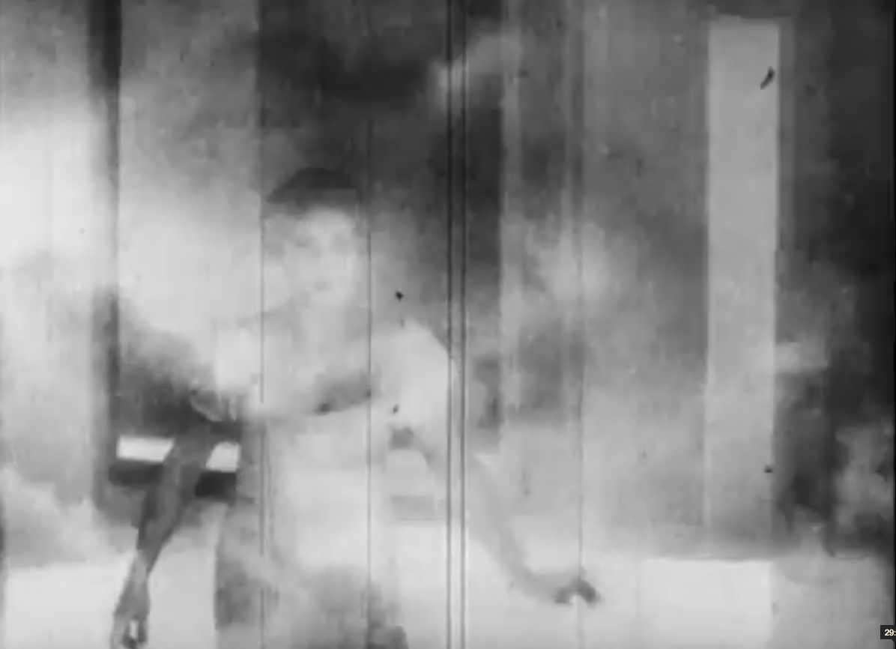

The Seashell and the Clergyman

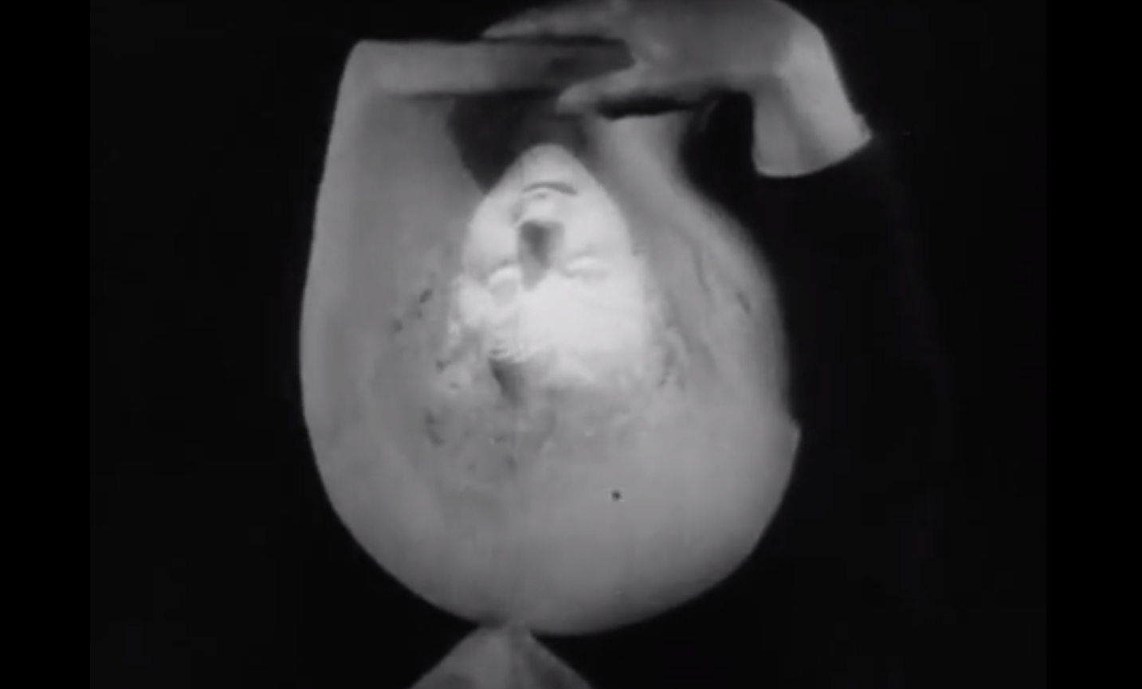

The Seashell and the Clergyman [La Coquille et le clergyman, 1926] serves as an early example of surrealist cinema. It was directed by French Impressionist filmmaker and theorist Germaine Dulac from a scenario by poet and dramatist Antonin Artaud. The film’s inaugural screening at Studio des Ursulines on February 9, 1928 gave rise to passionate outbursts from members of the surrealist community, relating primarily to Dulac’s allegedly unsatisfactory treatment of Artaud’s material. This legendary incident in many ways underscores Artaud and Dulac’s torrid and generative collaboration. Explicitly non-narrative, the film makes use of a wealth of cinematic devices (dissolves, superimpositions, masks, soft focus, unusual camera angles, slow motion, and repetition) to explore the clergyman’s struggle with eroticism and desire. While The Smiling Madame Bedeut (1922), Dulac’s previous film, induces the spectator to identify with Mme Bedeut, whose subjective consciousness generates the dreams and fantasies that comprise the film, The Seashell and the Clergyman dispenses with the notion of character and attempts a direct exploration of unconscious psychic processes. Eschewing narrative causation, the film follows an associative dream logic and prefigures Dulac’s later works of pure cinema [Cinéma pur], or films conceived according to the “rules of visual music.” Suspicious of the film’s lack of narrative progression and libidinal circulation of images, the British Board of Film Censors banned The Seashell and the Clergyman in 1927, describing it as “so cryptic as to be almost meaningless,” and concluding, “if there is meaning, it is doubtless objectionable.”

http://www.ubu.com/film/dulac_coquille.html

References:

Abel, R. (1988) French Film Theory and Criticism: A History/Anthology,1907-1939. Princeton: Princeton University Press.

Bordwell, D. (1980) French Impressionist Cinema: Film Culture, Film Theory, and Film Style. New York: Arno Press.
Dozoretz, W. (1979) “Dulac Versus Artaud.” Wide Angle 3.1: 46-53.
Flitterman-Lewis, S. (1990) To Desire Differently: Feminism and the French Cinema. Chicago: University of Illinois Press.
---. (1996) ‘The Image and the Spark: Dulac and Artaud Reviewed.’ Dada and Surrealist Film. Ed. Rudolf E. Kuenzli. Boston: MIT Press.
Williams, T. M. (2007) ‘Beyond Impressions: The Life and Films of Germaine Dulac from Aesthetics to Politics.’ Diss U. of California Los Angeles.
---. Sensations and Dreams: The Life and Films of Germaine Dulac. Urbana-Champaign: University of Illinois Press (forthcoming).

